**Lesson 2:**

* Control Flow
* Boolean expressions
* Logical operators
* Conditional execution
* Sequence of conditions
* Nested conditions
* Catching exceptions using try and except
* **Exercises**

**Note:**

**Control Flow**

A program's **control flow** is the order in which the program's code executes. The **control flow** of a **Python** program is regulated by conditional statements, loops, and function calls. Raising and handling exceptions also affects **control flow**;

**Boolean expressions**

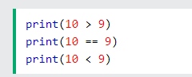

**Logical Operators**

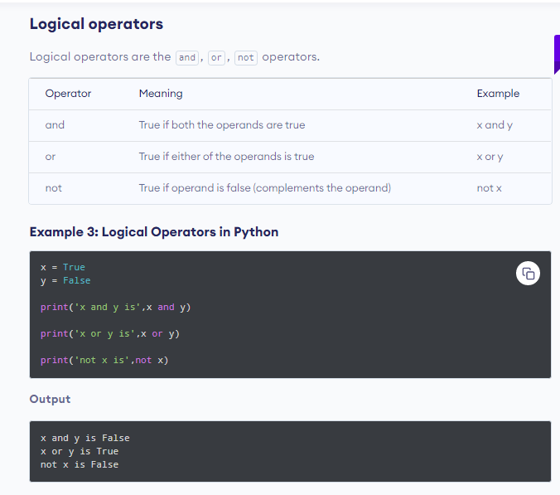

**Conditional Execution:**

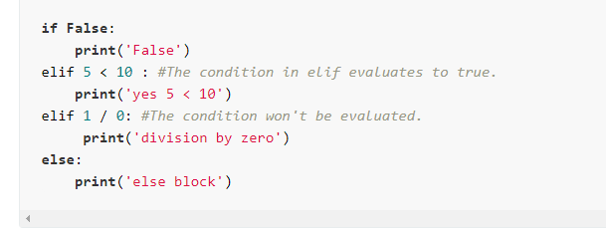

**Try/Except**

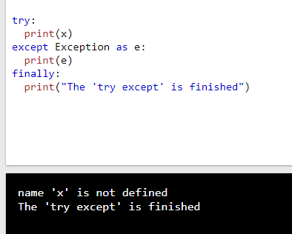

**Exercises:**

**Berilgan son musbat ,manfiy yoki 0 ga tengligi tekshirilsin.**

**1.Berilgan string ni boshiga ‘Hello’ so’zini qo’shish dasturi tuzilsin agar string ‘Hello’ bn boshlangan bo’lsa ‘Bu so’z Hello bilan boshlangan’ yozuvi ekranga chiqarilsin.(M: ‘Sardor’ –“Hello Sardor”)**

**2.Berilgan son juft yoki toqligi tekshirilsin.**

**3.Istalgan string kiritilsin va uzunligi 5 dan kichik bo’lsa False chiqarsin, 5dan kata 10 dan kichik bolsa True,10 dan kata bolsa stringni o’zi ekranga chiqsin.**

**4.Kiritilgan harf unli yoki undoshligi tekshirilsin.(Unli harflar:a,e,i,o,u.Qolgan barcha harflar undosh)**

**5.Kiritilgan 3 ta sondan 2 tasi bir xil bo’lsa 0 soni chiqarilsin aks holda uchala sonni yig’indisi ekranga chiqarilsin.**

**(M:1,2,3 - 6) (M:2,3,2 – 0)**

**6. Klaviaturadan 2 ta istalgan qiymat kiritilsin agar ularni ikkalasi ham son bolsa ularni ko’paytmasi ,agar string bolsa string+string,agar ikkalasi 2 xil tipda bolsa 0 ekranga chiqarilsin.**

**7.Istalgan 4 xonali son kiritilsin va raqamlari yig’indisi ekranga chiqarilsin.(M:4781 – 4+7+8+1=20)**

**8.Berilgan son 4 ga qoldiqsiz bo’linishi va 5 ga karraliligi tekshirilsin.**

**9.a=’Hello World’ stringdan foydalanib ekranga “ell orld” chqarilsin.**